Project Sassy (WIP)

Game Concept

Genre: Dungeon Crawler
Platform: PC
Target Audience: Us

Core Mechanics: Dungeon Exploration with light randomization and puzzle solving. Using different types of equipment to push your way through obstacles and delve deeper.

More specifically: A grid system like the ones in mistery dungeons and Void stranger.
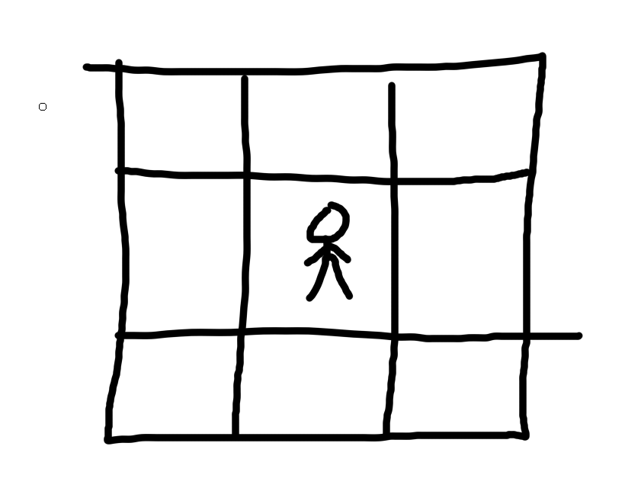
Since we have at least 4 types of weapons in the assets, I want different weapons to do different things. A turn system like fromm a mystery dungeon game where a move from you is followed by one from the active enemies. A way to make it so enemies can be randomized in every level, maybe allow for different things to show up in different rooms instead of enemies, like NPCs or items. Some way to generate enemies, like maybe an enemy generator of some kind in a room that spawns a set number of them that then wanders around while you explore.
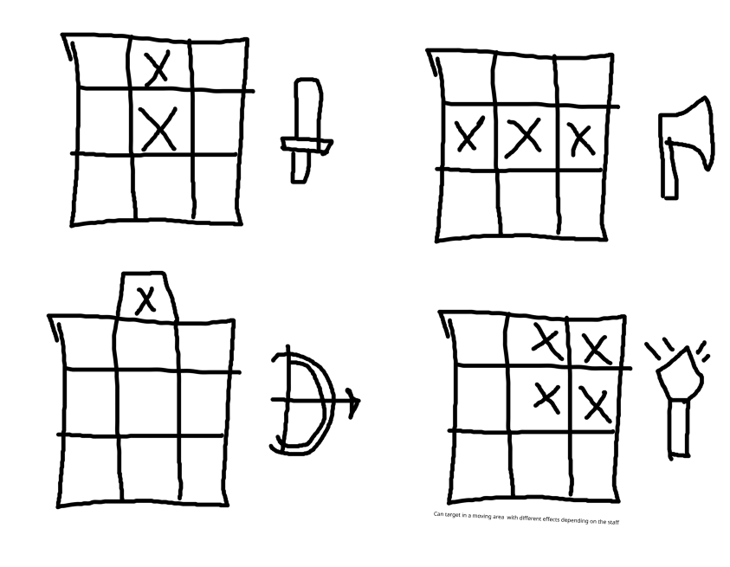
Story and Setting: The protagonist wakes up in a under a huge (huge) tree overlooking a city at the bottom of feet of a basin. He is an explorer, but his mind seems foggy. To his aid comes his pet, (have not decided what kind of pet), and adventuring partner and mapmaker, (don’t know a name yet). Apparently they came from very far away to explore the dungeons of the world tree. They get settled in town, taking requests from the townspeople and town officials that take them into the dungeons.
What is really going on: Her mapmaker partner is actually a (idk if a supercomputer or an otherwordly being) that gained sentience and fell in love with him in real life. A cataclysm (idk if the world got destroyed or nuclear war or something) made the world inhabitable, and the only solution the partner found was to trap keep them alive forever and hooking up their mind to a fantasy world where they could be happy. I’m planning for multiple endings depending on the player’s actions.

Art Style and Visuals: We already have those packs to work with. Anything we can’t make with what we have on hand may be made at some point in the future if it’s needed.

Inspirations: Etrian Oddysey, Mistery Dungeon games, Void Stranger, Disco Elysium, Machine Love, Nier.

